UECS3223 Cloud Computing
JAN 2024
Group Project
Group members
Name | Student ID | Trimester and year of study
1. Yap Ming Jun | 2106489 | Y2S2
2. Soon Yuan Hui | 2300611 | Y2S1
3. Wong Kai Quan | 2202909 | Y2S3
4. Seah Soon Lun | 2104488 | Y2S2
Marks breakdown
Parts | Marks allocated | Comments
a) Proper instructions on how to set up the workflow for the data analysis and / or ETL operations so that they run properly | / 20
b) Implementation of MapReduce / Spark applications or Hive / Spark SQL queries that perform AT LEAST 3 types of different analysis on the selected dataset. | / 30
c) Complexity of analysis performed; as given by the analysis algorithm implemented in MapReduce / Spark or the queries executed in Hive / Spark SQL | / 30
d) Proper explanation of the selected analysis being performed, along with comments in source code to explain how the analysis is achieved. | / 20
Total | / 100
General Information
Title: LIVEMart
Company Name: GitHub
Programming Language: Full Java
Source Code: https://github.com/abdulazeem-tk4vr/LIVEMart

Description:
The LIVEMart project is an e-commerce platform designed for Android devices, which simplifies the online grocery shopping experience for customers, retailers, and wholesalers. It enhances the user experience and meets the requirements of modern businesses. This project is entirely built using Java as the programming language for back-end development and window applications such as Android Studio as the IDE for Android app development and Firebase as the realtime database service provider. The general purpose of this project is to place order online or offline and browse through categories of products from various stores.
Object Startup:
To execute and compile this Android application, we require Android Studio. It serves as both the compiler for the application and the emulator for running the application in non-Android operating systems like Windows and macOS.
Basic Operation:
The system grants users the ability to carry out many functionalities, which including “Registration and Sign-Up”, “Add to cart”, “Online order”, “Offline order”, “Add Feedback”, “Add new product”, “Add or Update existing product”, and “Approve or Remove Items”.

Source Code Metrics and Listing of Components
- For the first step, all the java files from the “LiveMart” source code will be inserted into the databricks under “LiveMart” directory.
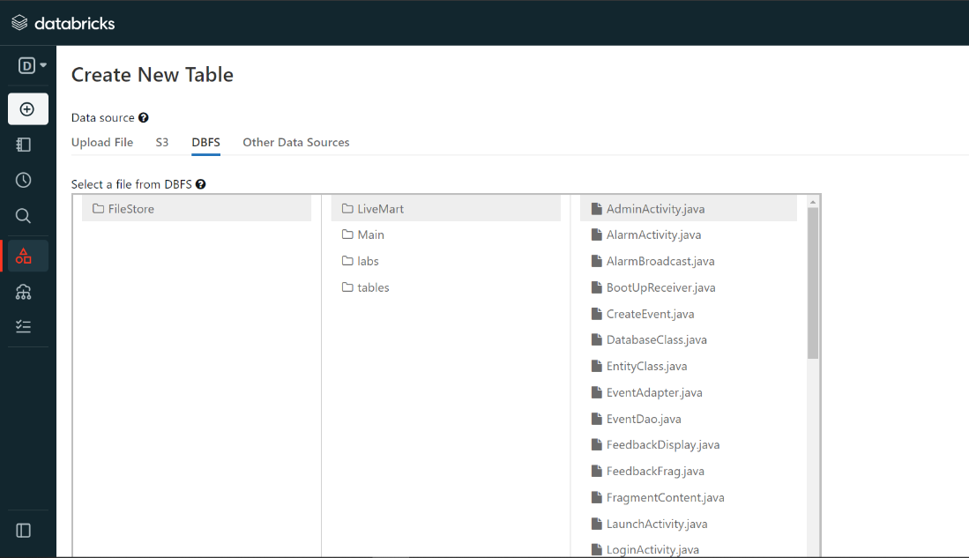
- Then, the total number of Java projects, lines, classes, abstract classes, libraries, public functions, private functions, constant variables, private variables, public variables, default variables, and protected functions from the source code will be calculated.
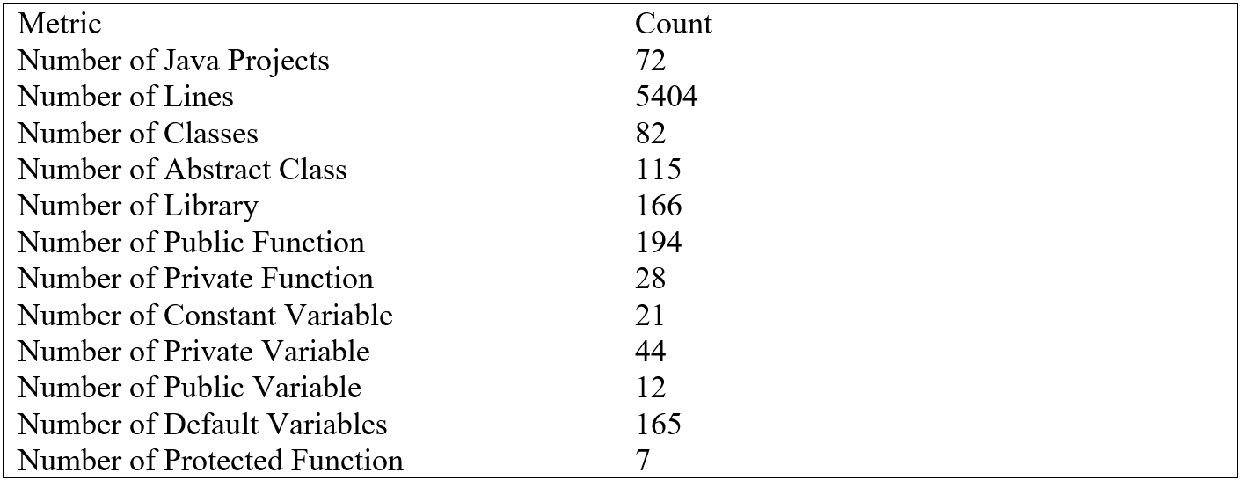
- Lastly, a txt file named “codeMetrics.txt” which contains all the data lists from Databrick will be downloaded by visiting the link below.
https://community.cloud.databricks.com/files/tables/data/codeMetrics.txt?o=8948525343260969#notebook/3798497699087034/command/1973268870636205
Code to list out the metrics and the output
1. Calculate Total of Java Project (javaProjectList.txt)
// Load files
val files = sc.wholeTextFiles("/FileStore/LiveMart/*")
// Define codeMetrics header
var codeMetrics = "\nMetric\t\t\t\t\tCount\n"
// Find java projects
val findJavaProjects = files.filter { case (filename, content) =>
filename.endsWith(".java")
}
// Collect java projects
val listJavaProjects = findJavaProjects.collect()
// Concatenate java projects
var javaProject =""
listJavaProjects.foreach(c => javaProject = javaProject + c + "\n")
// Save java projects list to file
dbutils.fs.put("/FileStore/tables/data/javaProjectList.txt", javaProject)
// Calculate total number of java projects
val numberOfJavaProjects = findJavaProjects.count()
// Update codeMetrics
codeMetrics = codeMetrics + "Number of Java Projects\t\t\t" + numberOfJavaProjects + "\n"
// Print codeMetrics for reference
println(codeMetrics)

Output: (From javaProjectList.txt)
Metric Count
Number of Java Projects 72
2. Calculate Number of Lines(linesList.txt)
// Load files
val files = sc.textFile("/FileStore/LiveMart/*")
// Define codeMetrics header
var codeMetrics = "\nMetric\t\t\t\t\tCount\n"
// Find lines
val findLines = files.filter (_.length>0)
// Collect lines
val listLines = findLines.collect()
// Concatenate lines
var lines =""
listLines.foreach(c => lines = lines + c + "\n")
// Save lines list to file
dbutils.fs.put("/FileStore/tables/data/linesList.txt", lines)
// Calculate total number of lines
val numberOfLine = findLines.count()
// Update codeMetrics
codeMetrics = codeMetrics + "Number of Lines\t\t\t\t" + numberOfLine + "\n"
// Print codeMetrics for reference
println(codeMetrics)

Output: (From linesList.txt)
Metric Count
Number of Lines 5404

3.Calculate Number of Classes (classList.txt)
// Load files
val files = sc.textFile("/FileStore/LiveMart/*")
// Define codeMetrics header
var codeMetrics = "\nMetric\t\t\t\t\tCount\n"
// Find classes
val findClass = files.filter(line => line.contains("public class"))
.filter(!_.contains("*"))
.map(_.split(" "))
.map(_(2))
// Collect class names
val listClass = findClass.collect()
// Concatenate class names
var className = ""
listClass.foreach(c => className = className + c + "\n")
// Save class list to file
dbutils.fs.put("/FileStore/tables/data/classList.txt", className)
// Calculate number of classes
val numberOfClass = findClass.count()
// Update codeMetrics with the number of classes
codeMetrics += s"Number of Classes\t\t\t$numberOfClass\n"
// Print codeMetrics for reference
println(codeMetrics)

Output: (From classList.txt)
CustomExpandableListAdapter
Admin
Adminsub
admin_subadapter

adminadapter

AdminActivity
AlarmActivity
AlarmBroadcast
BootUpReceiver
CreateEvent
CartActivity
CartAdapter

CustomerCart
CustomerCart_sub
CustomerCategories
CustomerOrders
CustomerOrders_sub
CustomerShopList

OrderAdapter

Shopadapter

TransModel_sub
adapter_sub

model_category
model_shop
model_subcategory
myadapterCustomerCategory

EntityClass
EventAdapter
FeedbackDisplay
FeedbackFrag
FragmentContent
FragmentNavigationManager
LaunchActivity
LoginActivity
MainActivity
Adapter_MyItems

MyItems
adapter_itemsub

item_sub
model_items_cat
model_itemsub
NavigationBar
NotificationMessage
RegisterActivity
CategoryAdapter

OrderAdapter

Orders_sub
RetailerCategories
RetailerOrders
RetailerOrders_sub
RetailerShopList
RetailerShopModel
RetailerShopadapter

RetailerSubCategories
RetailerTrans
RetailerTrans_sub
SubCategoryAdapter

TransModel
TransModel_sub
TransactionAdapter

SendOTPActivity
VerifyOTPActivity
Wholesaler_Add
addprodnoimage
addproduct
entermobilenumber
verifyenterotptwo

4. Calculate the number of abstract class (abstractClassList.txt)
// Filter lines to find abstract classes
val findAbstractClass = files
.filter(_.contains("class"))
.filter(line => line.contains("extends") || line.contains("implements"))
.map(_.trim)
.filter(!_.contains("*"))
.map(_.replaceAll("[{]", ""))
.distinct()

// Collect abstract class names into an array
val listAbstractClass = findAbstractClass.collect()

// Concatenate abstract class names into a single string
var abstractClassName = ""
listAbstractClass.foreach(c => abstractClassName = abstractClassName + c + "\n")

// Write abstract class names to a text file
dbutils.fs.put("/FileStore/tables/data/abstractClassList.txt", abstractClassName)

// Calculate number of abstract classes
val numberOfAbstractClass = findAbstractClass.count()

// Update codeMetrics with the number of abstract classes
codeMetrics = codeMetrics + s"Number of Abstract Class\t\t\t$numberOfAbstractClass\n"

Output: (From abstractClassList.txt)
public class adapter_sub extends FirebaseRecyclerAdapter<model_subcategory, adapter_sub.myviewholder>
public class AlarmBroadcast extends BroadcastReceiver
public class myviewholder extends RecyclerView.ViewHolder
public class SendOTPActivity extends AppCompatActivity
public class SubCategoryAdapter extends FirebaseRecyclerAdapter<model_subcategory, SubCategoryAdapter.myviewholder>
public class CustomerOrders_sub extends Fragment
public class OrderAdapter extends FirebaseRecyclerAdapter<TransModel_sub, OrderAdapter.myviewholder>
public class item_sub extends Fragment
public class LaunchActivity extends AppCompatActivity
public class RetailerOrders_sub extends Fragment
public class Wholesaler_Add extends Fragment
public class CustomerCart_sub extends Fragment
public class CustomerCategories extends Fragment
public class RetailerTrans extends Fragment implements AdapterView.OnItemClickListener
public class RegisterActivity extends AppCompatActivity implements LocationListener
class ViewHolder extends RecyclerView.ViewHolder
public class RetailerCategories extends Fragment
public class Shopadapter extends FirebaseRecyclerAdapter<model_shop, Shopadapter.myviewholder>
public class NavigationBar extends AppCompatActivity
public class adminadapter extends FirebaseRecyclerAdapter<model_category, adminadapter.myviewholder>
public class addprodnoimage extends AppCompatActivity
public class LoginActivity extends AppCompatActivity
public class CustomExpandableListAdapter extends BaseExpandableListAdapter
public class addproduct extends AppCompatActivity
public class AlarmActivity extends AppCompatActivity implements View.OnClickListener
public abstract class DatabaseClass extends RoomDatabase
public class CreateEvent extends AppCompatActivity implements View.OnClickListener
public class OrderAdapter extends FirebaseRecyclerAdapter<Orders_sub, OrderAdapter.myviewholder>
public class RetailerTrans_sub extends Fragment
public class RetailerShopList extends Fragment
public class RetailerOrders extends Fragment implements AdapterView.OnItemClickListener
public class admin_subadapter extends FirebaseRecyclerAdapter<model_subcategory, admin_subadapter.myviewholder>
public class NotificationMessage extends AppCompatActivity
//public class entermobilenumber extends AppCompatActivity
public class CartAdapter extends FirebaseRecyclerAdapter<Orders_sub, CartAdapter.myviewholder>
public class FragmentContent extends Fragment
public class BootUpReceiver extends BroadcastReceiver
public class CustomerShopList extends Fragment
public class CustomerSubCategories extends Fragment
public class CustomerCart extends Fragment implements AdapterView.OnItemClickListener
public class CartActivity extends Fragment
public class itemviewholder extends RecyclerView.ViewHolder
public class FragmentNavigationManager extends Fragment implements NavigationManager
public class CategoryAdapter extends FirebaseRecyclerAdapter<model_items_cat, CategoryAdapter.myviewholder>
public class VerifyOTPActivity extends AppCompatActivity
public class CustomerOrders extends Fragment implements AdapterView.OnItemClickListener
public class RetailerShopadapter extends FirebaseRecyclerAdapter<RetailerShopModel, RetailerShopadapter.myviewholder>
public class TransactionAdapter extends FirebaseRecyclerAdapter<com.example.oop_project.Main.Retailer.TransModel_sub, TransactionAdapter.myviewholder>
public class AdminActivity extends AppCompatActivity
public class myadapterCustomerCategory extends FirebaseRecyclerAdapter<model_category, myadapterCustomerCategory.myviewholder>
public class Admin extends Fragment
public class RetailerSubCategories extends Fragment
public class MyItems extends Fragment
public class Adapter_MyItems extends FirebaseRecyclerAdapter<model_items_cat, Adapter_MyItems.itemviewholder>
public class EventAdapter extends RecyclerView.Adapter<EventAdapter.ViewHolder>
public class Adminsub extends Fragment
//public class verifyenterotptwo extends AppCompatActivity
public class adapter_itemsub extends FirebaseRecyclerAdapter<model_itemsub,adapter_itemsub.myitemsubviewholder>
public class MainActivity extends AppCompatActivity
public class FeedbackDisplay extends Fragment
public class FeedbackFrag extends Fragment
public class myitemsubviewholder extends RecyclerView.ViewHolder

5. Calculate the number of interfaces (interfacesList.txt)
//Produce of interface list
val findInterface = files.filter(line => line contains "public interface")
.filter(!_.contains("*"))
.map(_.split(" "))
.map(_(2))
val listInterface = findInterface.collect
var interfaceName = ""
listInterface.foreach(c => interfaceName = interfaceName + c + "\n")
dbutils.fs.put("/FileStore/tables/data/interfaceList.txt",interfaceName)
//Calculate number of interface
val numberOfInterface = findInterface.count
codeMetrics = codeMetrics + "Number of Interface\t\t\t" + numberOfInterface + "\n"
Output: (From interfaceList.txt)
sharedpref
EventDao
NavigationManager

6. Calculate the number of libraries (libraryList.txt)
//Produce of import library list
val findImport = files.filter(line => line contains "import")
.distinct()
.sortBy(identity)
val libraryList = findImport.collect
var libraryName = ""
libraryList.foreach(c => libraryName = libraryName + c + "\n")
dbutils.fs.put("/FileStore/tables/data/libraryList.txt",libraryName)
//Calculate number of library
val numberOfLibrary = findImport.count
codeMetrics = codeMetrics + "Number of Library\t\t\t" + numberOfLibrary + "\n"
Output: (From libraryList.txt)
//import android.content.Intent;
//import android.os.Bundle;
//import android.text.Editable;
//import android.text.TextWatcher;
//import android.view.View;
//import android.widget.Button;
//import android.widget.EditText;
//import android.widget.ProgressBar;
//import android.widget.TextView;
//import android.widget.Toast;
//import androidx.annotation.NonNull;
//import androidx.appcompat.app.AppCompatActivity;
//import com.example.oop_project.Main.addproduct;
//import com.example.oop_project.R;
//import com.google.android.gms.tasks.OnCompleteListener;
//import com.google.android.gms.tasks.Task;
//import com.google.firebase.FirebaseException;
//import com.google.firebase.auth.AuthResult;
//import com.google.firebase.auth.FirebaseAuth;
//import com.google.firebase.auth.PhoneAuthCredential;
//import com.google.firebase.auth.PhoneAuthProvider;
//import java.util.concurrent.TimeUnit;
import android.Manifest;
import android.annotation.SuppressLint;
import android.app.AlarmManager;
import android.app.DatePickerDialog;
import android.app.Notification;
import android.app.NotificationChannel;
import android.app.NotificationManager;
import android.app.PendingIntent;
import android.app.TimePickerDialog;
import android.content.BroadcastReceiver;
import android.content.Context;
import android.content.DialogInterface;
import android.content.Intent;
import android.content.SharedPreferences;
import android.content.pm.PackageManager;
import android.content.res.Configuration;
import android.graphics.Typeface;
import android.location.Address;
import android.location.Geocoder;
import android.location.Location;
import android.location.LocationListener;
import android.location.LocationManager;
import android.net.Uri;
import android.opengl.Visibility;
import android.os.Build;
import android.os.Bundle;
import android.speech.RecognizerIntent;
import android.text.Editable;
import android.text.TextUtils;
import android.text.TextWatcher;
import android.util.Log;
import android.view.LayoutInflater;
import android.view.Menu;
import android.view.MenuItem;
import android.view.View;
import android.view.ViewGroup;
import android.widget.AdapterView;
import android.widget.ArrayAdapter;
import android.widget.BaseExpandableListAdapter;
import android.widget.Button;
import android.widget.DatePicker;
import android.widget.EditText;
import android.widget.ExpandableListAdapter;
import android.widget.ExpandableListView;
import android.widget.ImageView;
import android.widget.LinearLayout;
import android.widget.ListView;
import android.widget.ProgressBar;
import android.widget.RelativeLayout;
import android.widget.RemoteViews;
import android.widget.Spinner;
import android.widget.TextView;
import android.widget.TimePicker;
import android.widget.Toast;
import androidx.annotation.NonNull;
import androidx.annotation.Nullable;
import androidx.appcompat.app.ActionBarDrawerToggle;
import androidx.appcompat.app.AppCompatActivity;
import androidx.core.app.ActivityCompat;
import androidx.core.app.NotificationCompat;
import androidx.core.content.ContextCompat;
import androidx.core.view.GravityCompat;
import androidx.drawerlayout.widget.DrawerLayout;
import androidx.fragment.app.Fragment;
import androidx.fragment.app.FragmentManager;
import androidx.fragment.app.FragmentTransaction;
import androidx.recyclerview.widget.LinearLayoutManager;
import androidx.recyclerview.widget.RecyclerView;
import androidx.room.ColumnInfo;
import androidx.room.Dao;
import androidx.room.Database;
import androidx.room.Entity;
import androidx.room.Insert;
import androidx.room.PrimaryKey;
import androidx.room.Query;
import androidx.room.Room;
import androidx.room.RoomDatabase;
import com.bumptech.glide.Glide;
import com.example.oop_project.Main.Adapter.CustomExpandableListAdapter;
import com.example.oop_project.Main.Admin.Admin;
import com.example.oop_project.Main.Admin.Adminsub;
import com.example.oop_project.Main.AlarmActivity;
import com.example.oop_project.Main.Customer.CustomerCart;
import com.example.oop_project.Main.Customer.CustomerCategories;
import com.example.oop_project.Main.Customer.CustomerOrders;
import com.example.oop_project.Main.Customer.CustomerShopList;
import com.example.oop_project.Main.Customer.CustomerSubCategories;
import com.example.oop_project.Main.Customer.adapter_sub;
import com.example.oop_project.Main.Customer.model_category;
import com.example.oop_project.Main.Customer.model_subcategory;
import com.example.oop_project.Main.Customer.myadapterCustomerCategory;
import com.example.oop_project.Main.FeedbackDisplay;
import com.example.oop_project.Main.FeedbackFrag;
import com.example.oop_project.Main.FragmentContent;
import com.example.oop_project.Main.Helper.FragmentNavigationManager;
import com.example.oop_project.Main.Interface.NavigationManager;
import com.example.oop_project.Main.MainActivity;
import com.example.oop_project.Main.MyItems.model_items_cat;
import com.example.oop_project.Main.NavigationBar;
import com.example.oop_project.Main.Retailer.Orders_sub;
import com.example.oop_project.Main.Retailer.RetailerCategories;
import com.example.oop_project.Main.Retailer.RetailerOrders;
import com.example.oop_project.Main.Retailer.RetailerTrans;
import com.example.oop_project.Main.Wholesaler_Add;
import com.example.oop_project.Main.addprodnoimage;
import com.example.oop_project.R;
import com.firebase.ui.database.FirebaseRecyclerAdapter;
import com.firebase.ui.database.FirebaseRecyclerOptions;
import com.google.android.gms.tasks.Continuation;
import com.google.android.gms.tasks.OnCompleteListener;
import com.google.android.gms.tasks.OnFailureListener;
import com.google.android.gms.tasks.OnSuccessListener;
import com.google.android.gms.tasks.Task;
import com.google.firebase.FirebaseException;
import com.google.firebase.auth.PhoneAuthCredential;
import com.google.firebase.auth.PhoneAuthProvider;
import com.google.firebase.database.DataSnapshot;
import com.google.firebase.database.DatabaseError;
import com.google.firebase.database.DatabaseReference;
import com.google.firebase.database.FirebaseDatabase;
import com.google.firebase.database.Query;
import com.google.firebase.database.ValueEventListener;
import com.google.firebase.storage.FirebaseStorage;
import com.google.firebase.storage.StorageReference;
import com.google.firebase.storage.UploadTask;
import com.rey.material.BuildConfig;
import java.text.DateFormat;
import java.text.DecimalFormat;
import java.text.ParseException;
import java.text.SimpleDateFormat;
import java.util.ArrayList;
import java.util.Arrays;
import java.util.Calendar;
import java.util.Date;
import java.util.HashMap;
import java.util.List;
import java.util.Locale;
import java.util.Map;
import java.util.Random;
import java.util.TreeMap;
import java.util.concurrent.TimeUnit;
import java.util.regex.Matcher;
import java.util.regex.Pattern;
import static android.widget.Toast.LENGTH_LONG;

7. Calculate the number of public functions (publicFunctionList.txt )
// Load files
val files = sc.textFile("/FileStore/LiveMart/*")
// Produce number of public functions
val findPublicFunction = files.filter(line => line.contains("public"))
.filter(!_.contains("class"))
.filter(!_.contains("interface"))
.filter(_.contains("("))
.map(_.replaceAll("[{,;]", ""))
.map(_.trim)
.distinct()
.sortBy(identity)
// Collect public functions and save to file
val listPublicFunction = findPublicFunction.collect
var publicFunctionName = ""
listPublicFunction.foreach(c => publicFunctionName = publicFunctionName + c + "\n")
dbutils.fs.put("/FileStore/tables/data/publicFunctionList.txt", publicFunctionName)
// Calculate number of public functions
val numberOfPublicFunction = findPublicFunction.count
// Update codeMetrics with the number of public functions
var codeMetrics = ""
codeMetrics = codeMetrics + "Number of Public Function\t\t\t" + numberOfPublicFunction + "\n"
// Print codeMetrics for reference
println(codeMetrics)
Output: (From publicFunctionList.txt)
// public void onCodeSent(@NonNull String backendotp @NonNull PhoneAuthProvider.ForceResendingToken forceResendingToken)
// public void onComplete(@NonNull Task<AuthResult> task)
// public void onVerificationCompleted(@NonNull PhoneAuthCredential phoneAuthCredential)
// public void onVerificationFailed(@NonNull FirebaseException e)
// public void onCodeSent(@NonNull String verificationId @NonNull PhoneAuthProvider.ForceResendingToken forceResendingToken)
// public void onVerificationCompleted(@NonNull PhoneAuthCredential phoneAuthCredential)
// public void onVerificationFailed(@NonNull FirebaseException e)
// public void onCodeSent(@NonNull String newbackendotp @NonNull PhoneAuthProvider.ForceResendingToken forceResendingToken)
// public void onVerificationCompleted(@NonNull PhoneAuthCredential phoneAuthCredential)
// public void onVerificationFailed(@NonNull FirebaseException e)
// public void afterTextChanged(Editable s)
// public void beforeTextChanged(CharSequence s int start int count int after)
// public void onClick(View v)
// public void onClick(View view)
// public void onTextChanged(CharSequence s int start int before int count)
public Adapter_MyItems(@NonNull FirebaseRecyclerOptions<model_items_cat> options)
public Adminsub()
public Adminsub(String pname)
public CartAdapter(@NonNull FirebaseRecyclerOptions<Orders_sub> options)
public CategoryAdapter(@NonNull FirebaseRecyclerOptions<model_items_cat> options)
public CustomExpandableListAdapter(Context contextList<String> listTitleMap<StringList<String>> listItem)
public CustomerCart(ArrayList<String> Keys)
public CustomerCart_sub()
public CustomerCart_sub(String pname)
public CustomerCategories()
public CustomerOrders(ArrayList<String> Keys String pname)
public CustomerOrders_sub()
public CustomerOrders_sub(String pnameString custname)
public CustomerShopList()
public CustomerShopList(String catname String pnamedouble cutDistanceint qty)
public CustomerSubCategories()
public CustomerSubCategories(String pname)
public EventAdapter(Context context List<EntityClass> entityClasses)
public FeedbackDisplay(String fb)
public FeedbackFrag(String p_usertypeString p_usernameString arg_pnameString retname)
public FragmentContent()
public FragmentNavigationManager()
public MyItems()
public Object getChild(int groupPosition int childPosition)
public Object getGroup(int groupPosition)
public OrderAdapter(@NonNull FirebaseRecyclerOptions<Orders_sub> optionsContext c)
public OrderAdapter(@NonNull FirebaseRecyclerOptions<TransModel_sub> optionsContext c)
public Orders_sub()
public Orders_sub(String cost String ddate String dname String dnumber String pnameString price String quantityString shop String status)
public RetailerCategories()
public RetailerOrders(ArrayList<String> Keys)
public RetailerOrders_sub()
public RetailerOrders_sub(String pname)
public RetailerShopList()
public RetailerShopList(String catname String pname double cutDistancedouble qty)
public RetailerShopModel()
public RetailerShopModel(String latitude String longitude String price String quantity String rname)
public RetailerShopadapter(@NonNull FirebaseRecyclerOptions<RetailerShopModel> options Context context String catname String pname double cutDistint qty)
public RetailerSubCategories()
public RetailerSubCategories(String pname)
public RetailerTrans(ArrayList<String> Keysboolean t)
public RetailerTrans_sub()
public RetailerTrans_sub(String pnameboolean t)
public Shopadapter(@NonNull FirebaseRecyclerOptions<model_shop> options Context context String catname String pnamedouble cutDistint quantity)
public String FormatTime(int hour int minute)
public String getCost()
public String getDdate()
public String getDname()
public String getDnumber()
public String getEventdate()
public String getEventname()
public String getEventtime()
public String getImage()
public String getLatitude()
public String getLongitude()
public String getPname()
public String getPrice()
public String getQuantity()
public String getRname()
public String getShop()
public String getStatus()
public String getUsername()
public SubCategoryAdapter(@NonNull FirebaseRecyclerOptions<model_subcategory> options String category)
public Task<Uri> then(@NonNull Task<UploadTask.TaskSnapshot> task) throws Exception
public TransModel()
public TransModel(TransModel_sub t)
public TransModel_sub getT()
public TransModel_sub()
public TransModel_sub(String cost String ddate String dname String dnumber String pname String quantity String status String shop)
public TransModel_sub(String costString ddateString dnameString dnumberString pnameString quantityString statusString username)
public TransactionAdapter(@NonNull FirebaseRecyclerOptions<com.example.oop_project.Main.Retailer.TransModel_sub> options boolean t)
public View getChildView(int groupPosition int childPosition boolean isLastChild View convertView ViewGroup parent)
public View getGroupView(int groupPosition boolean isExpanded View convertView ViewGroup parent)
public View onCreateView(LayoutInflater inflater ViewGroup container
public ViewHolder onCreateViewHolder(@NonNull ViewGroup parent int viewType)
public ViewHolder(@NonNull View itemView)
public abstract EventDao EventDao()
public adapter_itemsub(@NonNull FirebaseRecyclerOptions<model_itemsub> options Context context)
public adapter_sub(@NonNull FirebaseRecyclerOptions<model_subcategory> optionsString category)
public admin_subadapter(@NonNull FirebaseRecyclerOptions<model_subcategory> options String category)
public adminadapter(@NonNull FirebaseRecyclerOptions<model_category> options)
public boolean hasStableIds()
public boolean isChildSelectable(int groupPosition int childPosition)
public boolean onChildClick(ExpandableListView parent View v int groupPosition int childPosition long id)
public boolean onCreateOptionsMenu(Menu menu)
public boolean onOptionsItemSelected(@NonNull MenuItem item)
public int getChildrenCount(int groupPosition)
public int getGroupCount()
public int getItemCount()
public item_sub()
public item_sub(String prod_type)
public itemviewholder onCreateViewHolder(@NonNull ViewGroup parent int viewType)
public itemviewholder(@NonNull View itemView)
public long getChildId(int groupPosition int childPosition)
public long getGroupId(int groupPosition)
public model_category()
public model_category(String image String pname)
public model_items_cat()
public model_items_cat(String image String pname)
public model_itemsub()
public model_itemsub(String pname String price String quantity)
public model_shop()
public model_shop(String latitudeString longitude String priceString quantityString rname)
public model_subcategory()
public model_subcategory(String image String pname String status)
public myadapterCustomerCategory(@NonNull FirebaseRecyclerOptions<model_category> options)
public myitemsubviewholder onCreateViewHolder(@NonNull ViewGroup parent int viewType)
public myitemsubviewholder(@NonNull View itemView)
public myviewholder onCreateViewHolder(@NonNull ViewGroup parent int viewType)
public myviewholder(@NonNull View itemView)
public myviewholder(@NonNull View view)
public static CustomerCategories newInstance(String param1 String param2)
public static CustomerShopList newInstance(String param1 String param2)
public static CustomerSubCategories newInstance(String param1 String param2)
public static DatabaseClass getDatabase(final Context context)
public static FragmentContent newInstance(String param1)
public static FragmentNavigationManager getminstance(NavigationBar mainActivity String username)
public static RetailerCategories newInstance(String param1 String param2)
public static RetailerShopList newInstance(String param1 String param2)
public static RetailerSubCategories newInstance(String param1 String param2)
public void afterTextChanged(Editable s)
public void beforeTextChanged(CharSequence s int start int count int after)
public void loadFragment(String title)
public void onBackPressed()
public void onBindViewHolder(@NonNull ViewHolder holder int position)
public void onCancelled(@NonNull DatabaseError error)
public void onCancelled(DatabaseError databaseError)
public void onClick(View v)
public void onClick(View view)
public void onCodeSent(@NonNull String newVerificationid @NonNull PhoneAuthProvider.ForceResendingToken forceResendingToken)
public void onComplete(@NonNull Task<Uri> task)
public void onComplete(@NonNull Task<Void> task)
public void onConfigurationChanged(@NonNull Configuration newConfig)
public void onCreate(Bundle savedInstanceState)
public void onDataChange(@NonNull DataSnapshot snapshot)
public void onDataChange(DataSnapshot dataSnapshot)
public void onDataChange(DataSnapshot snapshot)
public void onDataChanged()
public void onDateSet(DatePicker datePicker int year int month int day)
public void onDrawerClosed(View drawerView)
public void onDrawerOpened(View drawerView)
public void onError(@NonNull DatabaseError error)
public void onFailure(@NonNull Exception e)
public void onGroupCollapse(int groupPosition)
public void onGroupExpand(int groupPosition)
public void onItemClick(AdapterView<?> parent View view int position long id)
public void onLocationChanged(@NonNull Location location)
public void onProviderDisabled(@NonNull String provider)
public void onProviderEnabled(@NonNull String provider)
public void onReceive(Context context Intent intent)
public void onStart()
public void onStatusChanged(String provider int status Bundle extras)
public void onStop()
public void onSuccess(UploadTask.TaskSnapshot taskSnapshot)
public void onTextChanged(CharSequence s int start int before int count)
public void onTimeSet(TimePicker timePicker int i int i1)
public void onVerificationCompleted(@NonNull PhoneAuthCredential phoneAuthCredential)
public void onVerificationFailed(@NonNull FirebaseException e)
public void onViewCreated(@NonNull View view @Nullable Bundle savedInstanceState)
public void setCost(String cost)
public void setDdate(String ddate)
public void setDname(String dname)
public void setDnumber(String dnumber)
public void setEventdate(String eventdate)
public void setEventname(String eventname)
public void setEventtime(String eventtime)
public void setImage(String image)
public void setLatitude(String latitude)
public void setLongitude(String longitude)
public void setPname(String pname)
public void setPrice(String price)
public void setQuantity(String quantity)
public void setRname(String rname)
public void setShop(String shop)
public void setStatus(String status)
public void setT(TransModel_sub t)
public void setUsername(String username)
public void showFragment(Fragment fragmentContent boolean b)
public void showFragment(String parentItem String childItem)
8. Calculate the number of private functions (privateFunctionList.txt )
// Produce number of private functions
val findPrivateFunction = files.filter(line => line.contains("private"))
.filter(_.contains("("))
.filter(!_.contains("final"))
.filter(!_.contains(";"))
.map(_.replaceAll("[{}]", ""))
.map(_.trim)
.distinct()
.sortBy(identity)

// Collect private functions and save to file
val listPrivateFunction = findPrivateFunction.collect
var privateFunctionName = ""
listPrivateFunction.foreach(c => privateFunctionName = privateFunctionName + c + "\n")
dbutils.fs.put("/FileStore/tables/data/privateFunctionList.txt", privateFunctionName)

// Calculate number of private functions
val numberOfPrivateFunction = findPrivateFunction.count

// Update codeMetrics with the number of private functions
codeMetrics = codeMetrics + "Number of Private Function\t\t\t" + numberOfPrivateFunction + "\n"

// Print codeMetrics for reference
println(codeMetrics)
Output: (From privateFunctionList.txt)
// private void numberotpmove()
private double deg2rad(double deg)
private double distance(double lat1, double lon1, double lat2, double lon2)
private double rad2deg(double rad)
private void OpenGallery()
private void SaveProductInfoToDatabase()
private void StoreProductInformation()
private void ValidateEmail()
private void ValidateName()
private void ValidatePhone()
private void ValidateProductData()
private void ValidatePwd()
private void ValidateUser()
private void addDrawersItem()
private void configure(NavigationBar mainActivity)
private void gendata()
private void getLocation()
private void goToCreateEventActivity()
private void initItems()
private void recordSpeech()
private void selectDate()
private void selectFirstItemAsDefault()
private void selectTime()
private void setAdapter()
private void setAlarm(String text, String date, String time)
private void setupDrawer()
private void setupOTPInputs()
private void submit()

9. Calculate the number of constant variables (constantVariableList.txt )
// Produce number of constant variables
val findConstantVariable = files.filter(line => line.contains("final"))
.map(_.trim)
.distinct()
.sortBy(identity)
// Collect constant variables and save to file
val listConstantVariable = findConstantVariable.collect
var constantVariableName = ""
listConstantVariable.foreach(c => constantVariableName = constantVariableName + c + "\n")
dbutils.fs.put("/FileStore/tables/data/constantVariableList.txt", constantVariableName)
// Calculate number of constant variables
val numberOfConstantVariable = findConstantVariable.count
// Update codeMetrics with the number of constant variables
codeMetrics = codeMetrics + "Number of Constant Variable\t\t\t" + numberOfConstantVariable + "\n"
// Print codeMetrics for reference
println(codeMetrics)

Output: (From constantVariableList.txt)
// final Button setotp = findViewById(R.id.verify_otp);
// final ProgressBar progressBar1 = findViewById(R.id.progressbar_sendotp);
final Button buttonVerify = findViewById(R.id.verify_otp);
final DatabaseReference orders_Reference = rootref.child("User").child(user_type).child(username).child("Details");
final EditText inputMobile = findViewById(R.id.phone_number);
final FirebaseDatabase database = FirebaseDatabase.getInstance();
final ProgressBar progressBar = findViewById(R.id.progressbar_verifyotp);
final StorageReference filePath = ProductImagesRef.child(ImageUri.getLastPathSegment() + ".jpg");
final UploadTask uploadTask = filePath.putFile(ImageUri);
private static final String ARG_PARAM1 = "param1";
private static final String ARG_PARAM2 = "param2";
private static final String KEY_TITLE = "Content";
private static final int GalleryPick = 1;
protected void onBindViewHolder(@NonNull myviewholder holder, int position, @NonNull final Orders_sub model) {
protected void onBindViewHolder(@NonNull myviewholder holder, int position, @NonNull final RetailerShopModel model) {
protected void onBindViewHolder(@NonNull myviewholder holder, int position, @NonNull final TransModel_sub model) {
protected void onBindViewHolder(@NonNull myviewholder holder, int position, @NonNull final model_category model) {
protected void onBindViewHolder(@NonNull myviewholder holder, int position, @NonNull final model_items_cat model) {
protected void onBindViewHolder(@NonNull myviewholder holder, int position, @NonNull final model_shop model) {
protected void onBindViewHolder(@NonNull myviewholder holder, int position, @NonNull final model_subcategory model) {
public static DatabaseClass getDatabase(final Context context)
public static DatabaseClass getDatabase(final Context context) {

10. Calculate the number of private variables (privateVariableList.txt )
import scala.util.Try
// Produce number of private variables
val findPrivateVariable = files.filter(line => line.contains("private"))
.filter(!_.contains("("))
.filter(!_.contains("//"))
.filter(!_.contains("final"))
.map(_.replaceAll(";", ""))
.map(_.trim)
.distinct()
.sortBy(identity)
// Collect private variables
val listPrivateVariable = findPrivateVariable.collect
// Define file path
val privateVariableFilePath = "/FileStore/tables/data/privateVariableList.txt"
// Read existing content of the file, if any
val existingContent = Try(dbutils.fs.head(privateVariableFilePath)).getOrElse("")
// Append new content to existing content
val newContent = listPrivateVariable.mkString("\n") + "\n" + existingContent
// Write updated content back to the file
dbutils.fs.put(privateVariableFilePath, newContent, overwrite=true)
// Calculate the number of private variables
val numberOfPrivateVariable = findPrivateVariable.count
// Update codeMetrics with the number of private variables
codeMetrics = codeMetrics + "Number of Private Variable\t\t\t" + numberOfPrivateVariable + "\n"
// Print codeMetrics for reference
println(codeMetrics)
Output: (From privateVariableList.txt)
/*private String[] groupItem = {"Customer","Retailer","Wholesaler"}
private ActionBarDrawerToggle mDrawerToggle
private Button AddNewProductButton
private Button create, button_location
private Button joinNowButton, loginButton, navbartestButton
private Button login
private Context context
private DatabaseReference ProductsRef, UserData, Quantdata
private DatabaseReference ProductsRef,Quantityref,dbref,imageref
private DrawerLayout mDrawerLayout
private EditText InputName, InputPhoneNumber, InputPassword, ConfirmPassword, EmailID
private EditText iptn1, iptn2, iptn3, iptn4, iptn5, iptn6
private ExpandableListAdapter adapter
private ExpandableListView expandableListView
private FragmentManager mFragmentManager
private ImageView InputProductImage
private LinearLayout toplayout
private List<String> listTitle
private List<String> lstTitle
private Map<String,List<String>> listItem
private Map<String,List<String>> lstChild
private NavigationBar mainActivity
private NavigationManager navigationManager
private Spinner UserType
private Spinner product_type
private StorageReference ProductImagesRef
private String mActivityTitle
private String mParam1
private String mParam2
private String quantity, Price, Pname, p_username, nkey, category, temp_quantity
private String quantity,Price,Pname, downloadImageUrl,category,p_username,latitude,longitude
private String user_type
private String verificationId
private String[] items
private String[][] childItem = {{"Categories","Cart","orders","logout"},{"Categories","Cart","orders","add item","logout"},
private TextView Longitude_tfield, Latitude_tfield
private TextView eventText, timeAndDateText
private TextView pname , pquantity , pprice
private TextView pname, pquantity, pprice
private TextView t_username, t_password
private Uri ImageUri
private static DatabaseClass INSTANCE
private static FragmentNavigationManager mInstance
private static String p_username
/*private String[] groupItem = {"Customer","Retailer","Wholesaler"}

11. Calculate the number of public variables (publicVariableList.txt)
//Produce number of public variable
val findPublicVariable = files.filter(line => line contains "public" )
.filter(!_.contains("("))
.filter(_.contains(";"))
.map(_.replaceAll(";",""))
.map(_.trim)
.distinct()
.sortBy(identity)
//Collect public variables and save to file
val listPublicVariable = findPublicVariable.collect
var publicVariableName = ""
listPublicVariable.foreach(c => publicVariableName = publicVariableName + c + "\n")
dbutils.fs.put("/FileStore/tables/data/publicVariableList.txt",publicVariableName)
//Calculate number of public variables
val numberOfPublicVariable = findPublicVariable.count
//Update codeMetrics with number of public variables
codeMetrics = codeMetrics + "Number of Public Variable\t\t\t" + numberOfPublicVariable + "\n"
Output: (From publicVariableList.txt)
public String cust_uid = "M"
public String arg_cat,arg_pname,p_username,p_usertype, dist_temp,parent_usertype
public String fbtext="NO"
public String p_username, p_usertype
public String source
public String uid
public double cutoffDist
public double cutoffDistance
public int quantity
public int quantityDemand
public static String usertyp
public static int n=0

12. Calculate the number of default variables (defaultVariableList.txt)
// Define a regular expression to match variable declarations
val variableDeclarationPattern = """^\s*([a-zA-Z0-9_<>]+)\s+([a-zA-Z0-9_]+)\s*(=.*?)?;\s*$""".r
// Produce number of default variables
val findDefaultVariable = files.flatMap {
case variableDeclarationPattern(dataType, variableName, _) => Some(s"${dataType.trim} ${variableName.trim};")
case _ => None
}
.filter(!_.contains("return"))
.map(_.replaceAll(";", ""))
.map(_.trim)
.distinct()
.sortBy(identity)

// Collect default variables and save to file
val listDefaultVariable = findDefaultVariable.collect
var defaultVariableName = ""
listDefaultVariable.foreach(c => defaultVariableName = defaultVariableName + c + "\n")
dbutils.fs.put("/FileStore/tables/data/defaultVariableList.txt", defaultVariableName)

// Calculate number of default variables
val numberOfDefaultVariable = findDefaultVariable.count

// Update codeMetrics with number of default variables
codeMetrics = codeMetrics + "Number of Default Variable\t\t\t" + numberOfDefaultVariable + "\n"

Output: (From defaultVariableList.txt)
Adapter_MyItems adapter
AlarmManager am
AppCompatActivity activity
ArrayAdapter<String> adapter
ArrayList<String> Keys
ArrayList<String> text
Bundle args
Bundle bundle
Button admin
Button bt
Button buttonGetOTP
Button createEvent
Button filter
Button notifbtn
Calendar calendar
CartAdapter adapter
CategoryAdapter adapter
Context context
Context ct
CustomerCategories fragment
CustomerShopList fragment
CustomerSubCategories fragment
DatabaseClass databaseClass
DatabaseReference db
DatabaseReference dba
DatabaseReference dbref
DatabaseReference rootref
Date date1
DateFormat formatter
EditText cutDist
EditText cutoffDist
EditText editext_message
EditText et
EntityClass entityClass
EventAdapter eventAdapter
FragmentContent fragment
FragmentManager fm
FragmentTransaction ft
Geocoder geocoder
ImageView btn_record
ImageView img1
Intent galleryIntent
Intent i
Intent intent
Intent intent1
List<Address> addresses
List<EntityClass> classList
List<EntityClass> entityClasses
List<String> childitem1
List<String> childitem2
List<String> childitem3
List<String> title
ListView listview
LocationManager locationManager
Matcher matcher
Notification notification
NotificationChannel channel
NotificationManager notificationManager
OrderAdapter adapter
Pattern pattern
PendingIntent pendingIntent
PendingIntent pendingSwitchIntent
ProgressBar progressBar
Query query
Random random
RecyclerView recview
RecyclerView recview1
RecyclerView recyclerview
RelativeLayout rlayout
RemoteViews contentView
RetailerCategories fragment
RetailerShopList fragment
RetailerShopadapter adapter
RetailerSubCategories fragment
SharedPreferences sh
SharedPreferences sharedPreferences
Shopadapter adapter
Spinner mySpinner
Spinner s_usertype
String address
String catname
String channelId
String date
String dateandtime
String eventdate
String eventname
String eventtime
String fb
String firstItem
String formattedMinute
String latitude
String longitude
String mail
String message
String name
String number
String p_username
String p_usertype
String parentItem
String password
String phone
String pname
String prod_type
String product_username
String pwd
String regex
String regez_num
String repass
String repwd
String retname
String selectedFromList
String selectedItem
String shop_name
String source
String str
String str1
String str2
String str3
String str4
String temp
String text
String time
String timeTonotify
String title
String user
String user_type
String username
String usert
String value
SubCategoryAdapter adapter
TextView cutdisttext
TextView nametext
TextView status
TextView textView
TextView tview
TextView txtChild
TextView txtTitle
TransModel_sub t
TransactionAdapter adapter
View listHeaderView
View view
adapter_itemsub adapter
adapter_sub adapter
admin_subadapter adapter
adminadapter adapter
boolean t
double activeDist
double cutDist
double quantity
double theta
int a
int currentQuantity
int day
int hour
int id
int minute
int month
int newQuantity
int q
int qty
int qtyPresent
int quantity
int temp
int year
myadapterCustomerCategory adapter

13. Calculate the number of protected functions (protectedFunctionList.txt)
// Produce number of protected functions
val findProtectedFunction = files.filter(line => line.contains("protected"))
.filter(_.contains("("))
.filter(!_.contains("final"))
.filter(!_.contains(";"))
.map(_.replaceAll("[{}]", ""))
.map(_.trim)
.distinct()
.sortBy(identity)

// Collect protected functions and save to file
val listProtectedFunction = findProtectedFunction.collect
var protectedFunctionName = ""
listProtectedFunction.foreach(c => protectedFunctionName = protectedFunctionName + c + "\n")
dbutils.fs.put("/FileStore/tables/data/protectedFunctionList.txt", protectedFunctionName)

// Calculate number of protected functions
val numberOfProtectedFunction = findProtectedFunction.count

// Update codeMetrics with the number of protected functions
codeMetrics = codeMetrics + "Number of Protected Function\t\t\t" + numberOfProtectedFunction + "\n"
Output: (From protectedFunctionList.txt)
protected void onActivityResult(int requestCode, int resultCode, @Nullable Intent data)
protected void onBindViewHolder(@NonNull itemviewholder holder, int position, @NonNull model_items_cat model)
protected void onBindViewHolder(@NonNull myitemsubviewholder holder, int position, @NonNull model_itemsub model)
protected void onCreate(@Nullable Bundle savedInstanceState)
protected void onCreate(Bundle savedInstanceState)
protected void onPostCreate(@Nullable Bundle savedInstanceState)
protected void onResume()

14. Save code metrics to a txt file (codeMetrics.txt)
dbutils.fs.put("/FileStore/tables/data/codeMetrics.txt",codeMetrics)
Output: (codeMetrics.txt)
Metric  Number of Java Projects  Number of Lines  Number of Classes  Number of Abstract Class  Number of Library  Number of Public Function  Number of Private Function  Number of Constant Variable  Number of Private Variable  Number of Public Variable  Number of Default Variables  Number of Protected Function | Count  72  5404  82  115  166  194  28  21  44  12  165  7

List of components and subcomponents
- The code below is designed to display a list of parent class and sub class.
//Filter the extend classes out
val file=sc.textFile("/FileStore/tables/data")
val split=file.flatMap(x=>x.split(",")).map(x=>x.trim)
val classes=split.filter(!_.contains("//")).filter(!_.contains("/*")).filter(!_.contains("*")).filter(!_.contains("**")).filter(_.contains("class "))
val classes_distinct=classes.distinct
val extendsClass = classes_distinct.filter(_.contains("extends"))
val firstExtendsFilterClass=extendsClass.map(line=>line.replace("public","").replace("class","").replace("{","").replace("}","").replace("interface",""))
val secondExtendsFilterClass=firstExtendsFilterClass.map(line=>line.replace("extends","&").replace(" ","")).map(line=>line.split("&")).map(_.reverse)
//Filter the implement classes out
val implementsClasses = split.filter(_.contains("implements")).filter(!_.contains("//"))
val firstImplementsFilterClass=implementsClasses.map(line=>line.replace("public","").replace("class","").replace("{","").replace("}","").replace("interface",""))
val secondImplementsFilterClass=firstImplementsFilterClass.map(line=>line.replace("implements","&").replace(" ","")).map(line=>line.split("&")).map(_.reverse)
val class_child_parent = secondExtendsFilterClass ++ secondImplementsFilterClass
val a=class_child_parent.map(x => (x(0),x(1)))
a.collect
val df=a.toDF("Parent Class", "Sub Class")
df.show(100,false)
Output
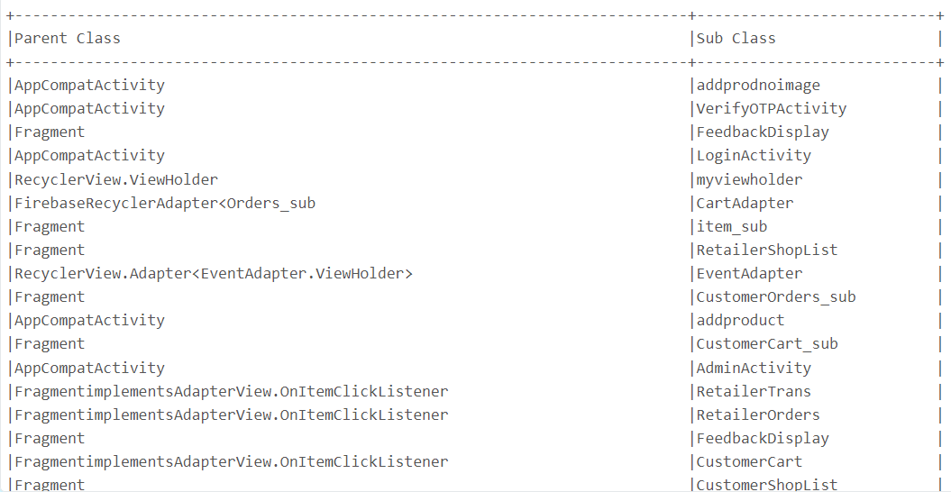
Search the specific components
- To search the specific components among the data, we will get all the classes in LiveMart in advance by using the code below.
import org.apache.hadoop.fs.{FileSystem,Path}
import scala.collection.mutable.ArrayBuffer
var privateVariableList = new ArrayBuffer[(String, String,
scala.collection.mutable.ArrayBuffer[String])]()
var publicVariableList = new ArrayBuffer[(String, String,
scala.collection.mutable.ArrayBuffer[String])]()
var constantVariableList =new ArrayBuffer[(String, String,
scala.collection.mutable.ArrayBuffer[String])]()
var interfaceList = new ArrayBuffer[(String, String, scala.collection.mutable.ArrayBuffer[String])]()
var abstractClassList = new ArrayBuffer[(String, String, scala.collection.mutable.ArrayBuffer[String])]()
var libraryList = new ArrayBuffer[(String, String, scala.collection.mutable.ArrayBuffer[String])]()
var privateFunctionList = new ArrayBuffer[(String, String,
scala.collection.mutable.ArrayBuffer[String])]()
var publicFunctionList = new ArrayBuffer[(String, String,
scala.collection.mutable.ArrayBuffer[String])]()
var defaultVariableList = new ArrayBuffer[(String, String,
scala.collection.mutable.ArrayBuffer[String])]()
var protectedFunctionList = new ArrayBuffer[(String, String,
scala.collection.mutable.ArrayBuffer[String])]()
var classList = new ArrayBuffer[(String, String,
scala.collection.mutable.ArrayBuffer[String])]()
var javaProjectList = new ArrayBuffer[(String, String,
scala.collection.mutable.ArrayBuffer[String])]()

def findPrivateVariables(files: Array[org.apache.hadoop.fs.FileStatus]) =
{
var total_RDD = new ArrayBuffer[(String, String, scala.collection.mutable.ArrayBuffer[String])]()
files.foreach(filename => {
val currentFile = filename.getPath.getName;
val data = sc.textFile(filename.getPath.toString)
val findPrivateVariable = data.filter(line => line contains "private" )
.filter(!_.contains("("))
.filter(!_.contains("//"))
.filter(!_.contains("final"))
.map(_.replaceAll(";",""))
.map(_.trim)
val functionArray = new ArrayBuffer[String]()
findPrivateVariable.collect.foreach(line => functionArray.append(line))
val resultRDD = (currentFile,"PrivateVariables",functionArray)
total_RDD.append(resultRDD)
})
privateVariableList = total_RDD
}

def findPublicVariables(files: Array[org.apache.hadoop.fs.FileStatus]) =
{
var total_RDD = new ArrayBuffer[(String, String, scala.collection.mutable.ArrayBuffer[String])]()
files.foreach(filename => {
val currentFile = filename.getPath.getName;
val data = sc.textFile(filename.getPath.toString)
val findPublicVariable = data.filter(line => line contains "public" )
.filter(!_.contains("("))
.filter(_.contains(";"))
.map(_.replaceAll(";",""))
.map(_.trim)
val functionArray = new ArrayBuffer[String]()
findPublicVariable.collect.foreach(line => functionArray.append(line))
val resultRDD = (currentFile,"PublicVariables",functionArray)
total_RDD.append(resultRDD)
})
publicVariableList = total_RDD
}

def findConstantVariables(files: Array[org.apache.hadoop.fs.FileStatus]) =
{
var total_RDD = new ArrayBuffer[(String, String, scala.collection.mutable.ArrayBuffer[String])]()
files.foreach(filename => {
val currentFile = filename.getPath.getName;
val data = sc.textFile(filename.getPath.toString)
val findConstantVariable = data.filter(line => line contains "final" )
.map(_.trim)
.distinct()
.sortBy(identity)
val functionArray = new ArrayBuffer[String]()
findConstantVariable.collect.foreach(line => functionArray.append(line))
val resultRDD = (currentFile,"ConstantVariables",functionArray)
total_RDD.append(resultRDD)
})
constantVariableList = total_RDD
}

def findInterfaceList(files: Array[org.apache.hadoop.fs.FileStatus]) =
{
var total_RDD = new ArrayBuffer[(String, String, scala.collection.mutable.ArrayBuffer[String])]()
files.foreach(filename => {
val currentFile = filename.getPath.getName;
val data = sc.textFile(filename.getPath.toString)
val findInterface = data.filter(line => line contains "public interface")
.filter(!_.contains("*"))
.map(_.split(" "))
.map(_(2))
val functionArray = new ArrayBuffer[String]()
findInterface.collect.foreach(line => functionArray.append(line))
val resultRDD = (currentFile,"InterfaceList",functionArray)
total_RDD.append(resultRDD)
})
interfaceList = total_RDD
}

def findAbstractClassList(files: Array[org.apache.hadoop.fs.FileStatus]) =
{
var total_RDD = new ArrayBuffer[(String, String, scala.collection.mutable.ArrayBuffer[String])]()
files.foreach(filename => {
val currentFile = filename.getPath.getName;
val data = sc.textFile(filename.getPath.toString)
val findAbstract = data.filter(line => line.contains("extends") || line.contains("implements"))
.map(_.trim)
.filter(!_.contains("*"))
.map(_.replaceAll("[{]",""))
.distinct()
val functionArray = new ArrayBuffer[String]()
findAbstract.collect.foreach(line => functionArray.append(line))
val resultRDD = (currentFile,"AbstractClassList",functionArray)
total_RDD.append(resultRDD)
})
abstractClassList = total_RDD
}

def findLibraryList(files: Array[org.apache.hadoop.fs.FileStatus]) =
{
var total_RDD = new ArrayBuffer[(String, String, scala.collection.mutable.ArrayBuffer[String])]()
files.foreach(filename => {
val currentFile = filename.getPath.getName;
val data = sc.textFile(filename.getPath.toString)
val findLibrary = data.filter(line => line contains "import")
.distinct()
.sortBy(identity)
val functionArray = new ArrayBuffer[String]()
findLibrary.collect.foreach(line => functionArray.append(line))
val resultRDD = (currentFile,"LibraryList",functionArray)
total_RDD.append(resultRDD)
})
libraryList = total_RDD
}

def findPrivateFunctionList(files: Array[org.apache.hadoop.fs.FileStatus]) =
{
var total_RDD = new ArrayBuffer[(String, String, scala.collection.mutable.ArrayBuffer[String])]()
files.foreach(filename => {
val currentFile = filename.getPath.getName;
val data = sc.textFile(filename.getPath.toString)
val findPrivateFunction = data.filter(line => line contains "private" )
.filter(_.contains("("))
.filter(!_.contains("final"))
.filter(!_.contains(";"))
.map(_.replaceAll("[{}]",""))
.map(_.trim)
.distinct()
.sortBy(identity)
val functionArray = new ArrayBuffer[String]()
findPrivateFunction.collect.foreach(line => functionArray.append(line))
val resultRDD = (currentFile,"PrivateFunctionList",functionArray)
total_RDD.append(resultRDD)
})
privateFunctionList = total_RDD
}

def findPublicFunctionList(files: Array[org.apache.hadoop.fs.FileStatus]) =
{
var total_RDD = new ArrayBuffer[(String, String, scala.collection.mutable.ArrayBuffer[String])]()
files.foreach(filename => {
val currentFile = filename.getPath.getName;
val data = sc.textFile(filename.getPath.toString)
val findPublicFunction = data.filter(line => line contains "public" )
.filter(!_.contains("class"))
.filter(!_.contains("interface"))
.filter(_.contains("("))
.map(_.replaceAll("[{,;]",""))
.map(_.trim)
.distinct()
.sortBy(identity)
val functionArray = new ArrayBuffer[String]()
findPublicFunction.collect.foreach(line => functionArray.append(line))
val resultRDD = (currentFile,"PublicFunctionList",functionArray)
total_RDD.append(resultRDD)
})
publicFunctionList = total_RDD
}

def findDefaultVariables(files: Array[org.apache.hadoop.fs.FileStatus]) = {
var total_RDD = new ArrayBuffer[(String, String, scala.collection.mutable.ArrayBuffer[String])]()
files.foreach(filename => {
val currentFile = filename.getPath.getName
val data = sc.textFile(filename.getPath.toString)
// Filter lines containing variable declarations with default values
val findDefaultVariable = data.filter(line => line.contains("=") && !line.contains("=="))
.map(_.trim)
.distinct()
.sortBy(identity)
val functionArray = new ArrayBuffer[String]()
findDefaultVariable.collect.foreach(line => functionArray.append(line))
val resultRDD = (currentFile, "DefaultVariables", functionArray)
total_RDD.append(resultRDD)
})
defaultVariableList = total_RDD
}

def findProtectedFunctions(files: Array[org.apache.hadoop.fs.FileStatus]) = {
var total_RDD = new ArrayBuffer[(String, String, scala.collection.mutable.ArrayBuffer[String])]()
files.foreach(filename => {
val currentFile = filename.getPath.getName
val data = sc.textFile(filename.getPath.toString)
// Filter lines containing protected function declarations
val findProtectedFunction = data.filter(line => line.contains("protected") && line.contains("("))
.map(_.replaceAll("[{}]","").trim) // Remove extra characters and trim
.distinct()
.sortBy(identity)
val functionArray = new ArrayBuffer[String]()
findProtectedFunction.collect.foreach(line => functionArray.append(line))
val resultRDD = (currentFile, "ProtectedFunctions", functionArray)
total_RDD.append(resultRDD)
})
protectedFunctionList = total_RDD
}

def findClasses(files: Array[org.apache.hadoop.fs.FileStatus]) = {
var total_RDD = new ArrayBuffer[(String, String, scala.collection.mutable.ArrayBuffer[String])]()
files.foreach(filename => {
val currentFile = filename.getPath.getName
val data = sc.textFile(filename.getPath.toString)
// Filter lines containing class declarations
val findClasses = data.filter(line => line.contains("class") && line.contains("{"))
.map(_.replaceAll("[{};]","").trim) // Remove extra characters and trim
.distinct()
.sortBy(identity)
val functionArray = new ArrayBuffer[String]()
findClasses.collect.foreach(line => functionArray.append(line))
val resultRDD = (currentFile, "Classes", functionArray)
total_RDD.append(resultRDD)
})
classList = total_RDD
}

def findJavaProjects(files: Array[org.apache.hadoop.fs.FileStatus]) = {
var total_RDD = new ArrayBuffer[(String, String, scala.collection.mutable.ArrayBuffer[String])]()
files.foreach(filename => {
val currentFile = filename.getPath.getName
val data = sc.textFile(filename.getPath.toString)
// Filter lines containing Java project structure patterns
val findJavaProjects = data.filter(line =>
line.contains("public class") || // Java classes
line.contains("package ") || // Package declarations
line.contains("import ") || // Import statements
line.contains("public static void main(") // Main method declarations
)
.map(_.trim)
.distinct()
.sortBy(identity)
val functionArray = new ArrayBuffer[String]()
findJavaProjects.collect.foreach(line => functionArray.append(line))
val resultRDD = (currentFile, "JavaProjects", functionArray)
total_RDD.append(resultRDD)
})
javaProjectList = total_RDD
}

def runProgram(): Unit = {

// Load files and perform analysis
val files = FileSystem.get(sc.hadoopConfiguration).listStatus(new Path("/FileStore/LiveMart"))
findPrivateVariables(files)
findPublicVariables(files)

// Process files and collect output
val output = privateVariableList.mkString("\n") +
"\n" +
publicVariableList.mkString("\n") +
"\n" +
constantVariableList.mkString("\n") +
"\n" +
interfaceList.mkString("\n") +
"\n" +
abstractClassList.mkString("\n") +
"\n" +
libraryList.mkString("\n") +
"\n" +
privateFunctionList.mkString("\n") +
"\n" +
publicFunctionList.mkString("\n")

// Write the output to a file
dbutils.fs.put("/FileStore/tables/data/searchComponentsList.txt", output, true)
// Close FileSystem
FileSystem.closeAll()
}

runProgram()
FileSystem.closeAll

- After that, a drop-down list with 2 buttons named “Class” and “Select Component” will be created in Databrick to offer selections for the user to check the class or component in a convenient way.
dbutils.widgets.dropdown("Class", "CustomExpandableListAdapter",
Seq("CustomExpandableListAdapter",
"Admin",
"Adminsub",
"admin_subadapter",
"adminadapter",
"AdminActivity",
"AlarmActivity",
"AlarmBroadcast",
"BootUpReceiver",
"CreateEvent",
"CartActivity",
"CartAdapter",
"CustomerCart",
"CustomerCart_sub",
"CustomerCategories",
"CustomerOrders",
"CustomerOrders_sub",
"CustomerShopList",
"OrderAdapter",
"Shopadapter",
"TransModel_sub",
"adapter_sub",
"model_category",
"model_shop",
"model_subcategory",
"myadapterCustomerCategory",
"EntityClass",
"EventAdapter",
"FeedbackDisplay",
"FeedbackFrag",
"FragmentContent",
"FragmentNavigationManager",
"LaunchActivity",
"LoginActivity",
"MainActivity",
"Adapter_MyItems",
"MyItems",
"adapter_itemsub",
"item_sub",
"model_items_cat",
"model_itemsub",
"NavigationBar",
"NotificationMessage",
"RegisterActivity",
"CategoryAdapter",
"OrderAdapter",
"Orders_sub",
"RetailerCategories",
"RetailerOrders",
"RetailerOrders_sub",
"RetailerShopList",
"RetailerShopModel",
"RetailerShopadapter",
"RetailerSubCategories",
"RetailerTrans",
"RetailerTrans_sub",
"SubCategoryAdapter",
"TransModel",
"TransModel_sub",
"TransactionAdapter",
"SendOTPActivity",
"VerifyOTPActivity",
"Wholesaler_Add",
"addprodnoimage",
"addproduct",
"entermobilenumber",
"verifyenterotptwo"
)
)

dbutils.widgets.dropdown("Select Component", "PrivateVariables",
Seq("PrivateVariables","PublicVariables","ConstantVariables","LibraryList","PrivateFunctionList","PublicFunctionList","InterfaceList","AbstractList","DefaultVariables","ProtectedFunction")
)

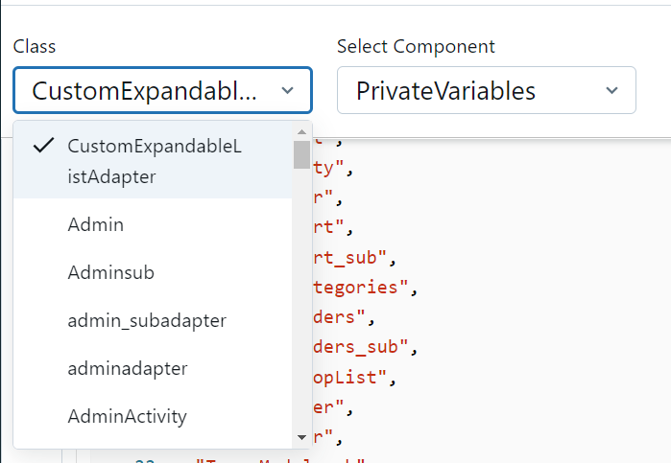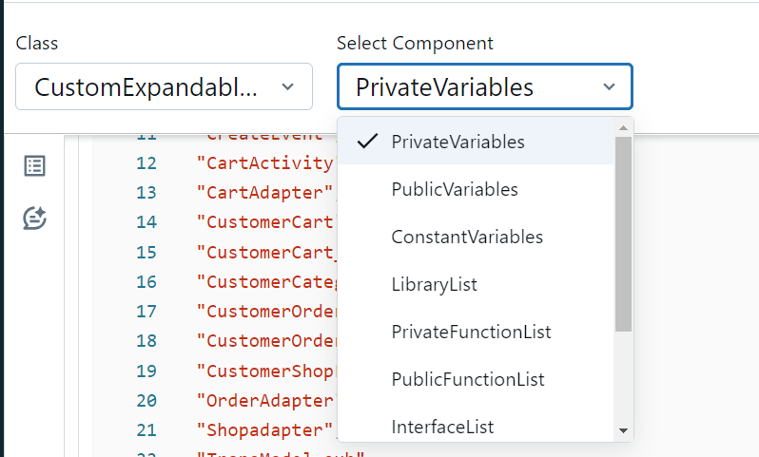

- The query from user will be processed by the code below to retrieve the requested data.
def runSearch(): Unit = {
val selectedClass = dbutils.widgets.get("Class")
val selectedComponent = dbutils.widgets.get("Select Component")
val componentList = ArrayBuffer("PrivateVariables", "PublicVariables", "ConstantVariables", "LibraryList", "PrivateFunctionList", "PublicFunctionList", "InterfaceList", "AbstractList")
if (componentList.contains(selectedComponent)) {
val listPointer = selectedComponent match {
case "PrivateVariables" => privateVariableList
case "PublicVariables" => publicVariableList
case "ConstantVariables" => constantVariableList
case "LibraryList" => libraryList
case "PrivateFunctionList" => privateFunctionList
case "PublicFunctionList" => publicFunctionList
case "DefaultVariables" => defaultVariableList
case "ProtectedFunction" => protectedFunctionList
case "InterfaceList" => interfaceList
case "AbstractClassList" => abstractClassList
}
println("====================")
for (row <- listPointer) {
if (row._1 == s"$selectedClass.java") {
if (row._3.nonEmpty) {
// Iterate over the components and print them, handling the case of duplicated 'id'
row._3.foreach { component =>
val trimmedComponent = component.trim
if (trimmedComponent.startsWith("public final Long id")) {
val enclosingClassName = selectedClass match {
case "SocketStatsWithId" => "SocketStatsWithId"
case "ServerStatsWithId" => "ServerStatsWithId"
case _ => "Unknown"
}
println(s"${enclosingClassName}.$trimmedComponent")
} else {
println(trimmedComponent)
}
}
} else {
println("Not Found")
}
}
}
println("====================")
} else {
println("Invalid component selected.")
}
}
runSearch()

3.1 User will be given choices for searching in specific class.
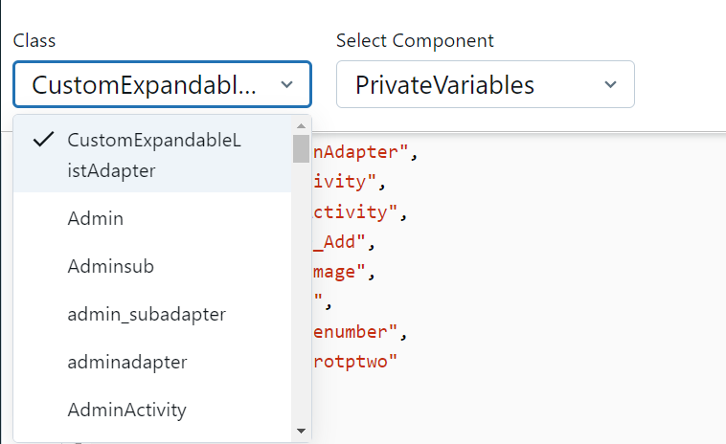
  - User will be given choices for searching in specific component.
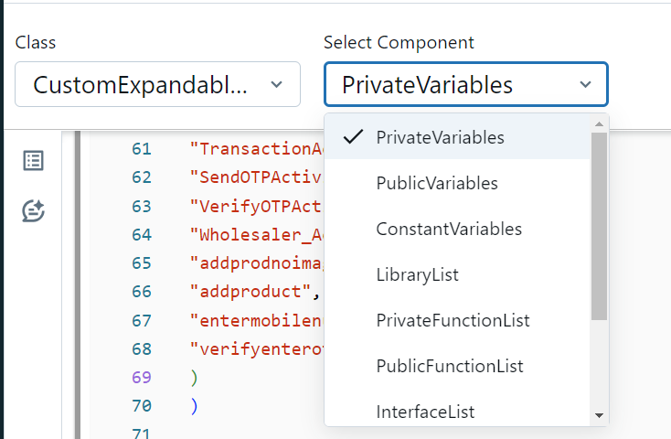
3.3 The output below shows the result of “PrivateVariable” component in “addproduct” class.
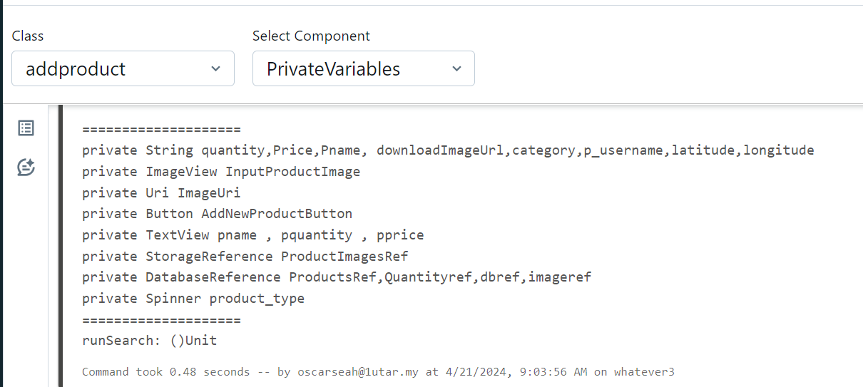

Dependency graph of the parent classes and subclasses
A dot file of the dependencies is created and the Graphviz software is used to generate the dependencies into a graph.
